**ASSIGMENT:4 DATE:18/01/2024**

**Pratical-1**

**AIM:Write a Program to add two numbers using pointers.**

Code:

#include <stdio.h>

int main() {

    int num1 = 10;

    int num2 = 20;

    int *ptr1 = &num1;

    int *ptr2 = &num2;

    int sum;

    sum = *ptr1 + *ptr2;

    printf("Sum of %d and %d is: %d\n", *ptr1, *ptr2, sum);

return 0;

 }

Output: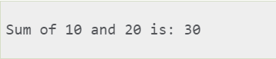

**Pratical-2**

**Aim:Write a program to implement call by value and call by reference.**

**#include<stdio.h>**

**void swap(int , int);**

**//prototype of the function**

**int main()**

**{ int a = 10;**

**int b = 20;**

**printf("Before swapping the values in main a = %d, b = %d\n",a,b); swap(a,b);**

**printf("After swapping values in main a = %d, b = %d\n",a,b);**

**}**

**void swap (int a, int b)**

**{**

**int temp;**

**temp = a;**

**a=b;**

**b=temp; printf("After swapping values in function a = %d, b = %d\n",a,b);**

**}**

**Output:**

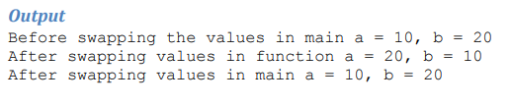

**Pratical-3**

**Aim:Write a Program to multiply two values using pointers.**

**Code:**

**#include<stdio.h>**

**int main()**

**{**

**int a, b, *p, *q, mul;**

**printf(“Enter integer a: “);**

**scanf(“%d”, &a);**

**printf(“Enter integer b: “);**

**scanf(” %d”, &b);**

**p = &a;**

**q = &b;**

**mul = *p * *q;**

**printf(“\nMultiplication of the numbers: %d”, mul);**

**return 0;**

**}**

**Output:**

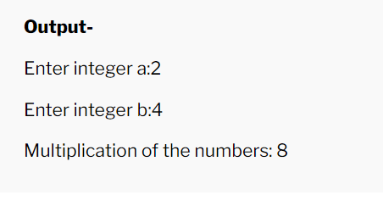

**Pratical-4**

**Aim:Write a program to print the memory scale used by different data types.**

**Code:**

**#include <stdio.h>**

**int main() {**

**// Sizes of different data types in C**

**printf("Size of char: %lu bytes\n", sizeof(char));**

**printf("Size of int: %lu bytes\n", sizeof(int));**

**printf("Size of float: %lu bytes\n", sizeof(float));**

**printf("Size of double: %lu bytes\n", sizeof(double));**

**return 0;**

**}**

**Output:**

